

ALI RAZA
9864
DSA –SECTION (A)
BSCS

REVISION LAB NO 01

- Task no 01:

Write a program that:
1. Takes integer n
2. If positive print even numbers till n
3. If negative print odd numbers till -1
4. If zero print message.

Program:

#include <iostream>
using namespace std;

int main() {
int n;
cout << "Enter an integer: ";
cin >> n;

if (n > 0) {
cout << "Even numbers " << n << ":" << endl;
for (int i = 2; i <= n; i += 2) {
cout << i << " ";
}
cout << endl;
}
else if (n < 0) {
cout << "Odd numbers " << endl;
for (int i = -1; i >= n; i -= 2) {
cout << i << " ";
}
cout << endl;
}
else {
cout << "You entered zero, no numbrs to display" << endl;
}

return 0;
}

Output:
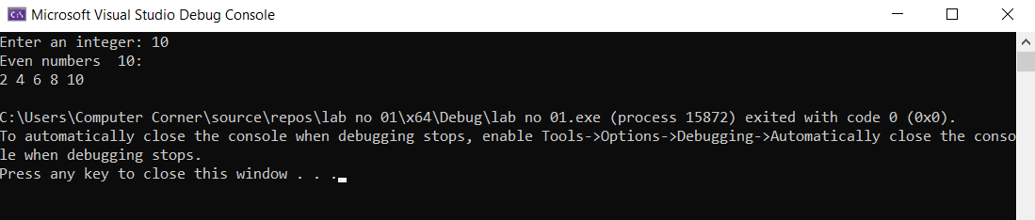

- Task no 02:

Student Result Processing System: A university wants a simple result system for a class. Write a program that Takes:
Total number of students Marks (out of 100) For each student:
- If marks ≥ 85 → Print "A Grade"
- If marks ≥ 70 and < 85 → Print "B Grade"
- If marks ≥ 50 and < 70 → Print "C Grade"
- Else → Print "Fail"
At the end, print:
- Number of passed students
- Number of failed students
Constraints:
- Use loops for repeated input.
- Use if-else ladder for grading.
- Use appropriate data types.

Program:

#include <iostream>
using namespace std;

int main() {
int totalStudents;
cout << "Enter total number of students: ";
cin >> totalStudents;

int marks;
int passed = 0, failed = 0;

for (int i = 1; i <= totalStudents; i++) {
cout << "Enter marks of student " << i << ": ";
cin >> marks;

if (marks >= 85) {
cout << "A Grade" << endl;
passed++;
}
else if (marks >= 70) {
cout << "B Grade" << endl;
passed++;
}
else if (marks >= 50) {
cout << "C Grade" << endl;
passed++;
}
else {
cout << "Fail" << endl;
failed++;
}
}

cout << " Number of passed students: " << passed << endl;
cout << "Number of failed students: " << failed << endl;

return 0;
}

Output:

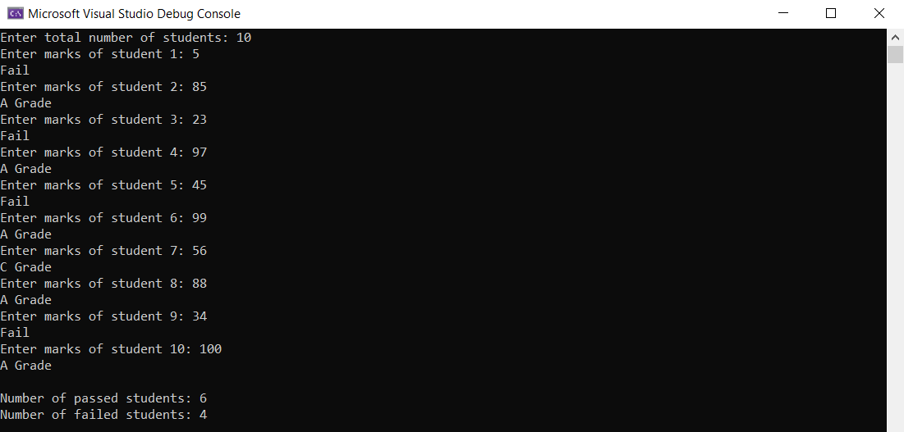

- Task 03:
Write a function my_power which takes two parameters, i.e. base & exponent, and returns result after calculations (result = base ^{exponent}). (Note: you cannot use built-in functions.)
Prototype of the function must be
double my_power(double base, double exp);

Program:

#include <iostream>
using namespace std;

double my_power(double base, double exp) {

if (exp == 0)
return 1;

double result = 1;
int e = (int)exp;

if (e > 0) {
for (int i = 0; i < e; i++) {
result *= base;
}
}
else {
for (int i = 0; i < -e; i++) {
result *= base;
}
result = 1.0 / result;
}

return result;
}

int main() {
cout << my_power(2, 3) << endl;
cout << my_power(5, 0) << endl;
cout << my_power(2, -2) << endl;
return 0;
}

Output:

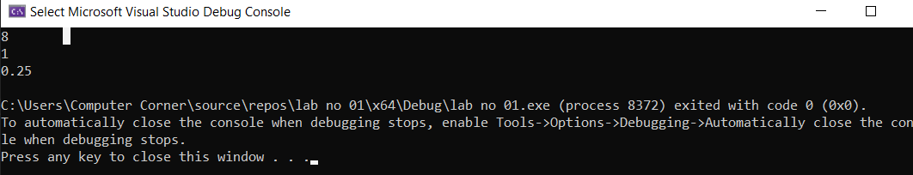

- Task no 04:

You have an array of integers representing scores of students. Your task:
- Find the minimum and maximum elements in the array
- Swap these two values using a swap function that uses pass by reference only
Display should be:
- Array before swapping
- Array after swapping

Program:

#include <iostream>
using namespace std;

void my_swap(int& a, int& b) {
int temp = a;
a = b;
b = temp;
}

int main() {
int arr[] = { 45, 78, 23, 89, 12, 67 };
int n = sizeof(arr) / sizeof(arr[0]);

cout << "Array before swapping: ";
for (int i = 0; i < n; i++) {
cout << arr[i] << " ";
}
cout << endl;

int minIndex = 0, maxIndex = 0;
for (int i = 1; i < n; i++) {
if (arr[i] < arr[minIndex]) minIndex = i;
if (arr[i] > arr[maxIndex]) maxIndex = i;
}

my_swap(arr[minIndex], arr[maxIndex]);

cout << "Array after swapping: ";
for (int i = 0; i < n; i++) {
cout << arr[i] << " ";
}
cout << endl;

return 0;
}

Output:
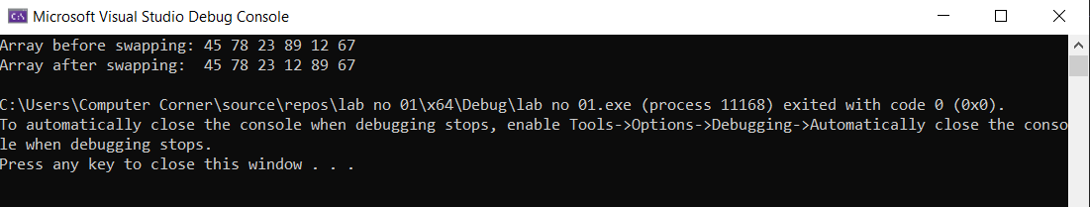

- Task no 05

Copy the following program, compile it and observe the output.
// This program demonstrates the ability of a pointer to
// point to different variables.
#include <iostream>
using namespace std;

int main()
{
int x = 25, y = 50, z = 75; // Three int variables
int *ptr; // Pointer variable

// Display the contents of x, y, and z.
cout << "Here are the values of x, y, and z:\n";
cout << x << " " << y << " " << z << endl;

// Use the pointer to manipulate x, y, and z.

ptr = &x; // Store the address of x in ptr
*ptr *= 2; // Multiply value in x by 2

ptr = &y; // Store the address of y in ptr
*ptr *= 2; // Multiply value in y by 2

ptr = &z; // Store the address of z in ptr
*ptr *= 2; // Multiply value in z by 2

//Display the contents of x, y, and z.
cout << "Once again, here are the values "
<< "of x, y, and z:\n";
cout << x << " " << y << " " << z << endl;
return 0;
}

Program:

#include <iostream>
using namespace std;

int main()
{
int x = 25, y = 50, z = 75;
int* ptr;

cout << "Here are the values of x, y, and z:\n";
cout << x << " " << y << " " << z << endl;

ptr = &x;
*ptr *= 2;

ptr = &y;
*ptr *= 2;

ptr = &z;
*ptr *= 2;

cout << "Once again, here are the values " << "of x, y, and z:\n";
cout << x << " " << y << " " << z << endl;
return 0;
}

Output:

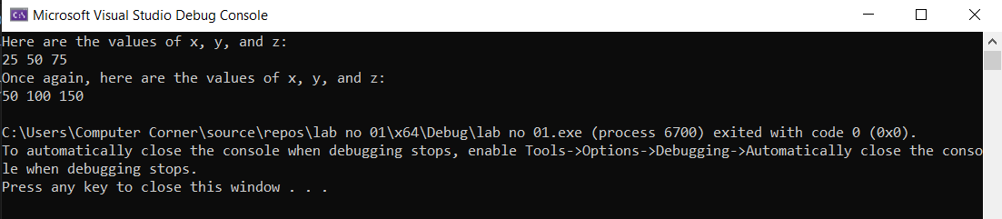

- Task no 06:
Write a function:
void updateValue(int &x);
This function should:
- If x is even → multiply it by 3
- If x is odd → add 7
Keep in mind:
- Take a number from the user
- Call the function
Display the updated value.

Program:

#include <iostream>
using namespace std;

void updateValue(int& x) {
if (x % 2 == 0) {
x = x * 3;
}
else {
x = x + 7;
}
}
int main() {
int num;
cout << "Enter a number: ";
cin >> num;

updateValue(num);
cout << "Updated value: " << num << endl;

return 0;
}

Output:
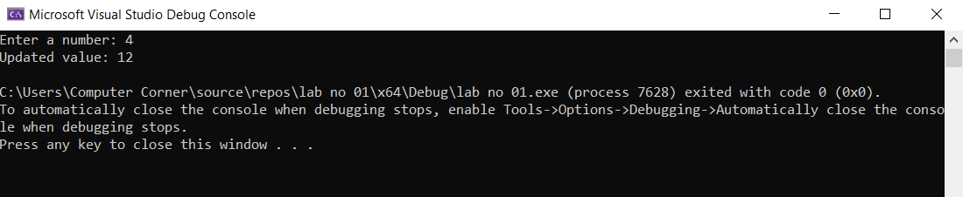
- Task no 07:

A teacher wants to store the marks of 5 students dynamically.
Write a C++ program to:
- Dynamically allocate memory to store marks of 5 students.
- Take marks as input from the user.
- Print the marks.
- Free the allocated memory.

Program:

#include <iostream>
using namespace std;

int main() {
int* marks;
int n = 5;

marks = new int[n];
cout << "Enter marks of " << n << " students:" << endl;
for (int i = 0; i < n; i++) {
cin >> marks[i];
}

cout << "Marks of students are: ";
for (int i = 0; i < n; i++) {
cout << marks[i] << " ";
}
cout << endl;
delete[] marks;

return 0;
}

Output:

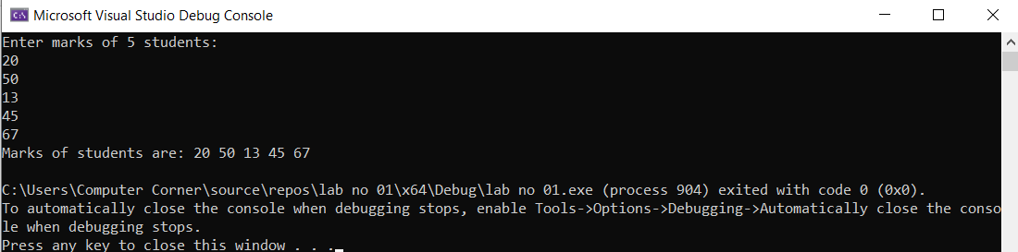
- Task no 08:

Write a program to calculate the area using function overloading:
Area of a rectangle (length × breadth)
Area of a circle (π × radius²)
Area of a square (side × side)

Program:

#include <iostream>
using namespace std;
double area(double length, double breadth) {
return length * breadth;
}
double area(double radius) {
double PI = 3.14159;
return PI * radius * radius;
}
int area(int side) {
return side * side;
}

int main() {
cout << "Area of rectangle : " << area(5.0, 3.0) << endl;
cout << "Area of circle: " << area(4.0) << endl;
cout << "Area of square: " << area(6) << endl;
return 0;
}

Output:

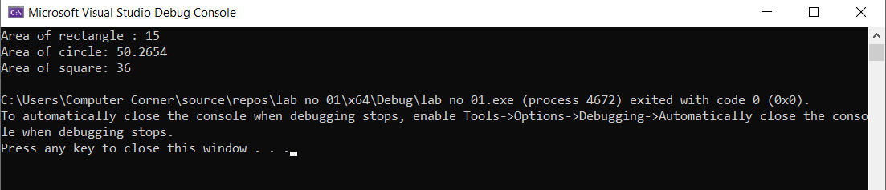
- Task no 09:

Write a function template sum to add two numbers of any type and return the result.

Program:
#include <iostream>
using namespace std;

template <typename T>
T sum(T a, T b) {
return a + b;
}
int main() {
cout << "Sum of integers: " << sum(5, 7) << endl;
cout << "Sum of doubles: " << sum(3.5, 2.8) << endl;
return 0;
}

Output:
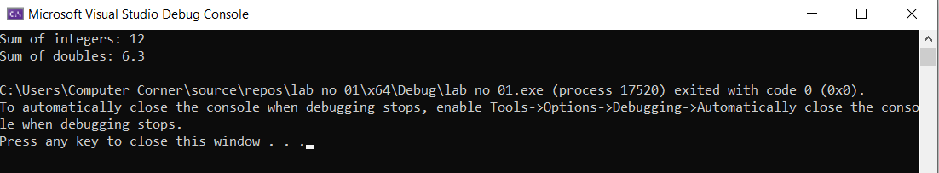
- Task no 10:

Write a function template to display a Date or Time in a formatted way.

Use a template so the same function works for both Date (day, month, year) and Time (hours, minutes, seconds).
Take input from the user and print the formatted result.
Example:
Input | Output
Date: 21 1 2026 | 21/01/2026
Time: 14 30 45 | 14:30:45

Program:

#include <iostream>
using namespace std;

template <typename T>
void display(T a, T b, T c, char sep) {
if (a < 10) cout << "0";
cout << a << sep;
if (b < 10) cout << "0";
cout << b << sep;
if (c < 10) cout << "0";
cout << c << endl;
}
int main() {
int day, month, year;
cout << "Enter Dat (day month year): ";
cin >> day >> month >> year;
cout << "Formated Date: ";
display(day, month, year, '/');

int h, m, s;
cout << "Enter Time (hours minut seconds): ";
cin >> h >> m >> s;
cout << "Formatted Time: ";
display(h, m, s, ':');

return 0;
}

Output:

